**FIRE ALARM SYSTEM**

**HARDWARE COMPONENTS**

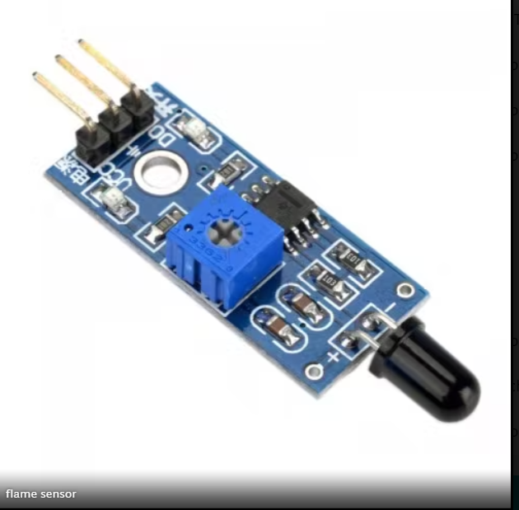

Flame Sensor

Flame sensor is used to detect the presence of a fire or any other strong light source. A Flame Sensor can be implemented in a variety of methods, but the one utilized in this project is an Infrared Radiation Sensitive Sensor.

A LM393 comparator chip is used to create a reliable digital output signal in the module. This comparator has a 15 mA driving capability. This flame detector sensor can be utilized in a variety of applications, such as fire alarms and other fire detection devices or projects.

Specifications

* LM393 comparator chip
* Detection Range: 760 nm to 1100 nm
* Operating Voltage: 3.3 V to 5 V
* Maximum Output Current: 15 mA
* Digital Outputs: 0 and 1 Detection Angle: about 60 degrees
* Adjustable sensitivity via potentiometer
* LED lights indicators: power (red) and digital switching output (green)

Smoke Sensor

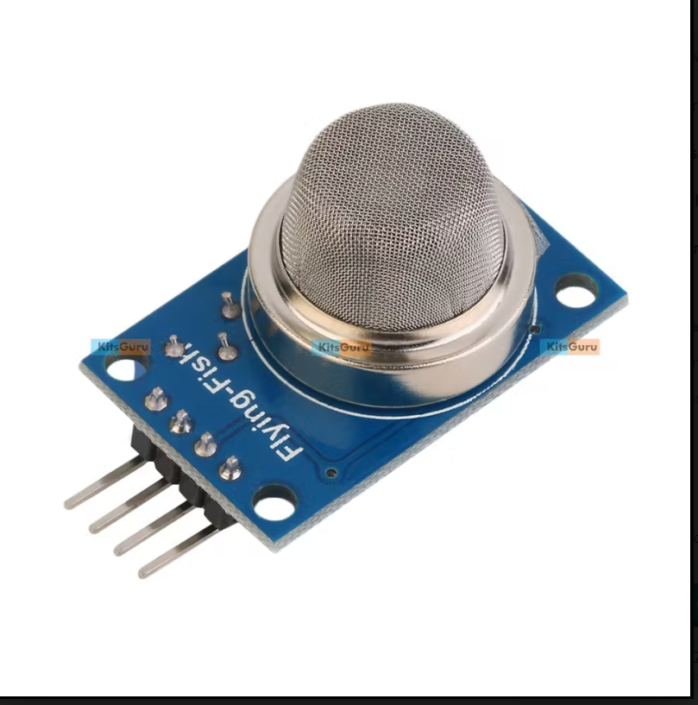

In our project we use a smoke sensor which is use to detect gas such as Methane, Butane and LPG.

Specifications:

* Operating Voltage is +5V
* Can be used to Measure or detect LPG, Alcohol, Propane, Hydrogen, CO and even methane
* Analog output voltage: 0V to 5V
* Digital Output Voltage: 0V or 5V (TTL Logic)
* Preheat duration 20 seconds
* Can be used as a Digital or analog sensor
* The Sensitivity of Digital pin can be varied using the potentiometer

NODE MCU ESP8266

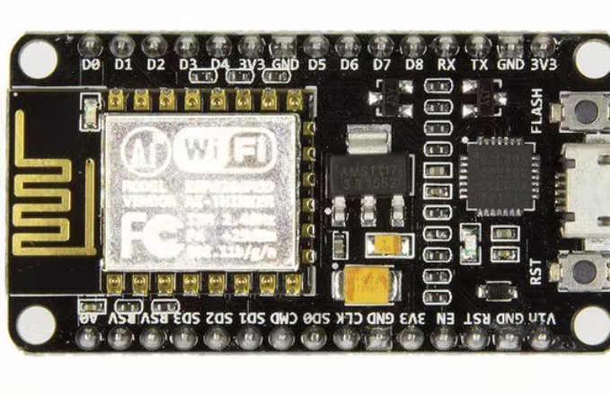

It comprises firmware that operates on Espressif Systems' low-cost Wi-Fi enabled ESP8266 Wi-Fi SoC and hardware that is based on the ESP-12 module. It has GPIO, SPI, I2C, ADC, PWM, and UART pins for controlling and communicating with other devices.

The CP2102 IC on board the NodeMCU provides USB to TTL capabilities. We use two GPIO pins in this IoT Fire Alarm to obtain digital data from the flame sensor and gas sensor.

Specifications:

Amica NodeMCU measures 49mm x 26mm with a standard pin space of 0.1″ between pins and 0.9″ between rows.

The Amica NodeMCU is approximately 25% smaller in size than a closely compatible LoLin style NodeMCU.